[1]

Characterizing the Neutron Energy Distribution of the AFIT Building 470 Graphite Pile

(May 2018)

Will D. Johnston, *Master’s Student, NENG 725, Department of Engineering Physics, Air Force Institute of Technology*

*Abstract*—Monte Carlo N-Particle Transport Code simulations can be used to characterize the neutron energy distribution throughout the graphite pile in the Air Force Institute of Technology’s Building 470 due to a plutonium-beryllium neutron source. The energy distribution is determined by using a grid of point detectors and compared to simulations with full and partially removed stringers to characterize the effects of air gaps necessary for a lab experiment. The energy distributions in individual stringers behave as one may imagine as a whole containing higher counts in the detectors closest to the source with the distribution shifting in weight toward lower energies further from the source. It is also shown that partially or fully removing a stringer has a negligible effect on the energy distribution at that point.

*Index Terms*—graphite pile, neutron energy distribution, neutron moderation, MCNP, image degradation

# INTRODUCTION

E

veryday cameras can be used to approximate yields of a nuclear weapon detonation in an urban environment by relative intensity changes and frequency shift in color cameras. The silicon operational amplifiers and pixels in these cameras, though, will be affected by the neutron output of the weapon due to lattice displacement. Image degradation can be experimentally characterized by placing a camera recording an image of constant intensity near a neutron source while tracking intensity, frequency dependence, and pixel changes. To determine the optimal placement of the camera in a graphite pile with a plutonium-beryllium (PuBe) neutron source, Monte Carlo N-Particle (MCNP) Transport Code simulations are run to characterize the energy distribution at various points in the pile as well as how full and partial pissing stringers will change the distribution.

# Schematics of the Graphite Pile

The graphite pile was designed in March 1962 by the Nuclear Engineering Test Facility, Directorate of Engineering Test, Aeronautical Systems Division, Air Force Systems Command, Wright-Patterson Air Force Base, Ohio.

The pile consists of five materials: graphite for neutron moderation, a PuBe source to produce neutrons, cadmium to block thermal neutrons from exiting and entering, aluminum to insulate and protect the pile, and wooden supports. The graphite pile is 50” x 50” wide and 72” in height, surrounded on the sides and top by a 1/32” cadmium shield enclosed by an aluminum honeycombed insulating panel, and rests on a 1/2” aluminum slab above aluminum “I” beams for support. The graphite is arranged in 18 crossed layers of 12 - 4” x 4” x 50” stringers allowing for a one-inch overlap on either side of the short face of the stringer.

## Source and Removable Stringers

The pile contains 15 removable stringers, one of which contains the PuBe source. Nine of the removable stringers are positioned facing the side of the pile with the other five and source stringer facing the front. Four of the five front facing stringers are separated into two groups and placed to where when both are removed they create a larger space to insert larger materials and detectors.

Figure 1 displays the pile with the source stringer labeled “S”, removable stringers labeled “S#”, and the double stringers labeled as one in accordance with their numbers in the simulation. One of the removable double stringers is not showed due to the cutaway of the cadmium and aluminum and but is symmetric across the middle with the other double stringer.

# Method

Monte Carlo N-Particle (MCNP) Transport Code, developed by Los Alamos National Lab, is used to simulate neutrons traveling through the graphite pile and tally the energy distribution at different points and in volumes.



Fig. 1. Cutaway drawing of the graphite pile showing the source and removable stringers.

## Assumptions

Since certain aspects of this scenario can be strenuous to model and can take high computational time, some assumptions can be made to reduce the time and variance of the results.

Assumptions:

* the wood supports are ignored due to their negligible contribution
* the graphite is modeled as a solid 50” x 50” x 72” block
* the aluminum “I” beams are ignored because the documentation is not clear on their design
* aluminum enclosing is 31/32” because documentation is not clear
* the source is a 3” x 1” radius cylinder because the documentation is not clear
* the source is beryllium only because of the negligible contribution of plutonium
* outside the aluminum casing is modeled as a void that kills neutrons entering that cell because the probability of scattering back into the pile is sufficiently small
* the output energy distribution is determined from an experiment as shown in Figure 2.
* Source strength is 1.006x107 neutrons per second [1]

## Composition of the MCNP Code

Two detectors and one tally type are used to characterize the neutron energy distribution in the pile: point (F5) and volume (F4) detectors with energy distribution tallies. The point detectors implement a built-in variance reduction technique to reduce the number of neutrons needed to achieve statistically good results.



Fig. 2. Energy distribution of the PuBe source.

In this technique, when a scatter event happens, the particle is “split” into two particles with different weights. One of these particles continues to travel normally while the other is transported directly to a sphere of radius 1/2 the average mean free path of a neutron in graphite. The splitting of the particle allows for the point detector to detect neutrons without having

to run the code for an unreasonable number of particles. The weights balance out the extra particles created by accurately scaling the probabilities within the transport. The volume detectors do not use a variance reduction technique since the volume of the detector is sufficiently large relative to the pile.

The energy distribution tallies are separated into 46 bins with a max of 1.964 MeV. There is also a cut-off card that kills neutrons below thermal energy (0.025 eV) to reduce computation time. One billion particles are transported for the two volume tallies but only approximately 4.5 million for the point detectors due to computational time constraints.

# Results

Overall, the energy distributions of the individual stringers behave the way one may imagine. Figures 3, 4, and 5 show the stringers that are farther away from the source have lower energy counts with distributions shifting toward lower energy ranges due to the increased possibility of scattering events. The side points of the stringers perpendicular to the source stringer are similar as expected since because of the symmetry. This symmetry also follows to the double stringers on either side of the source, not shown in a figure to reduce unnecessary repetition of plots.

The partially removed stringer is representative of a volume detector placed at the end of stringer five allowing for most of the graphite to stay inserted while the fully removed stringer represents a volume detector in the center of the empty space surrounded by air. Figures 6 and 7 show that the neutron energy distribution of the partially and fully removed stringer is similar enough to their point detector counter parts to conclude that having the spacing needed in a lab experiment has a negligible effect.

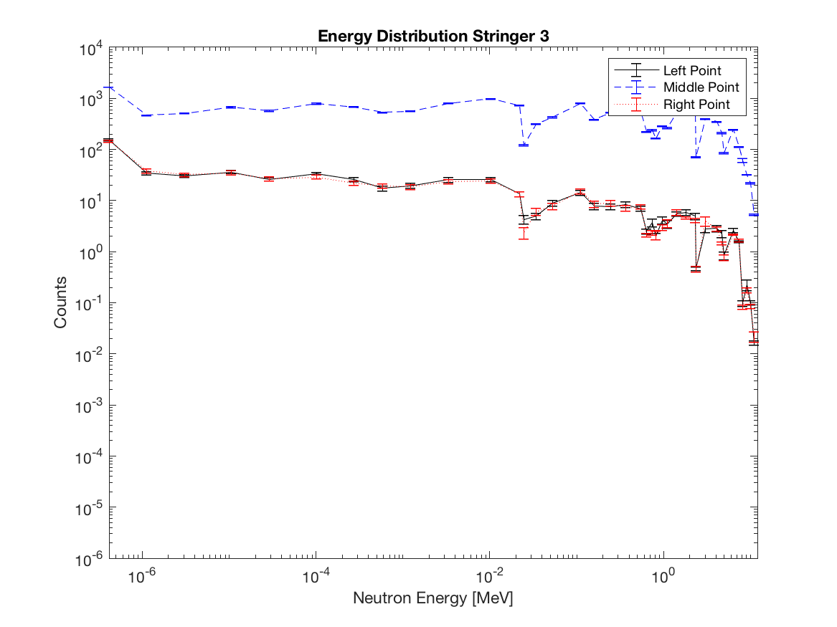

Fig. 3. Neutron energy distribution at three points in Stringer 3.

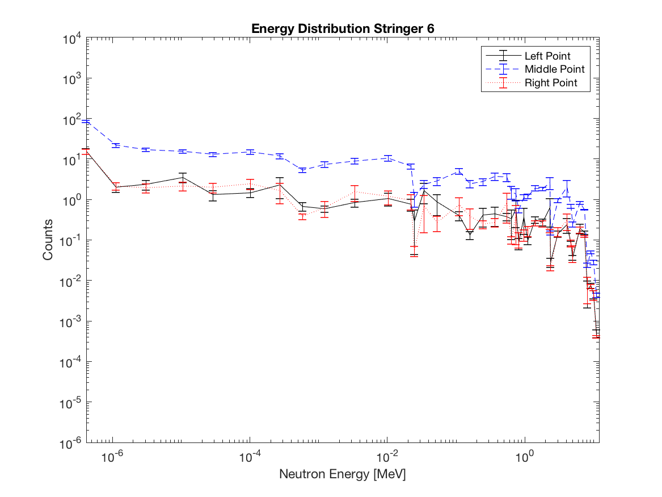

Fig. 4. Neutron energy distribution at three points in Stringer 6.

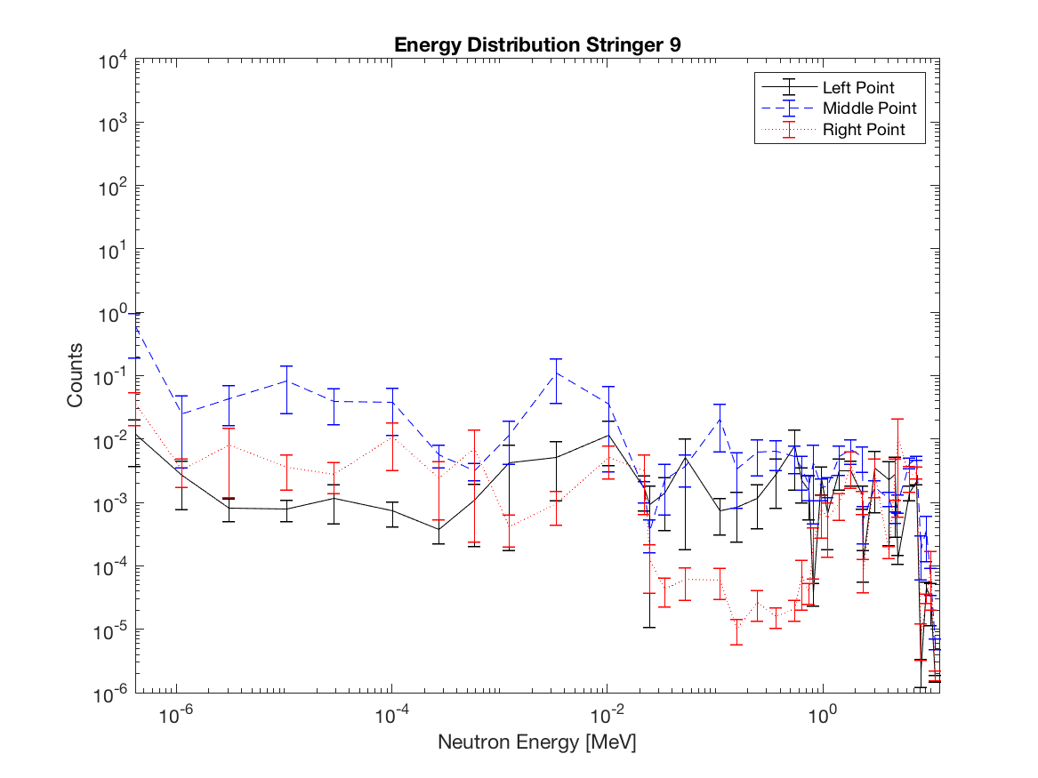

Fig. 5. Neutron energy distribution at three points in Stringer 9.

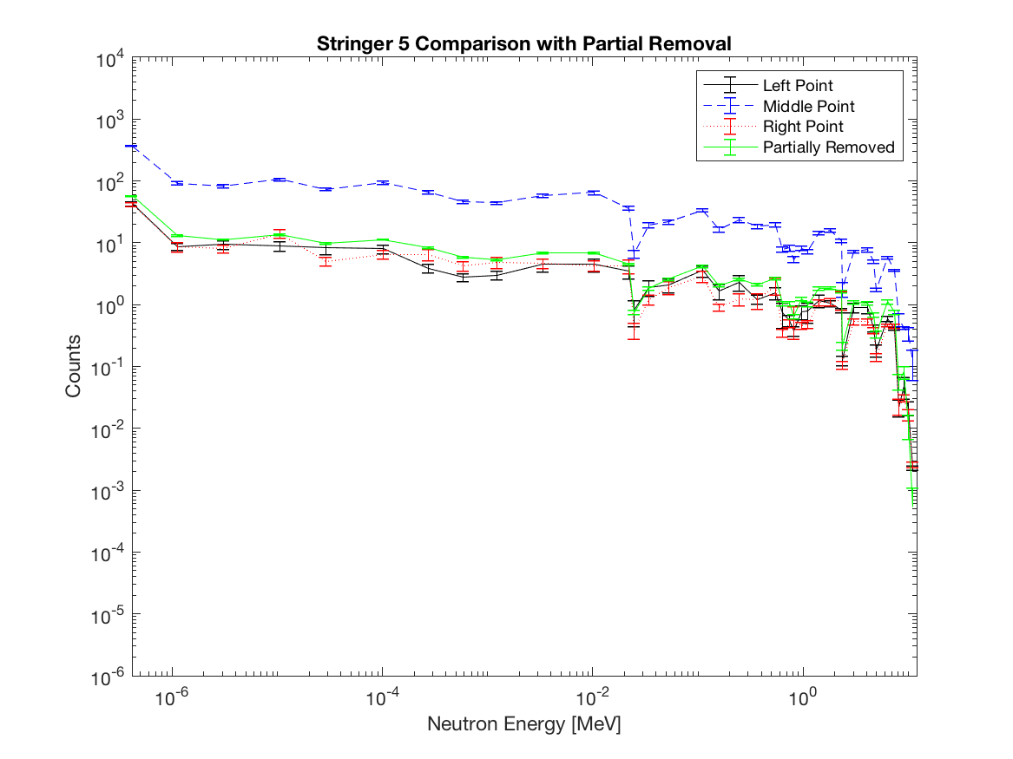

Fig. 6. Neutron energy distribution comparison of the partially removed stringer 5 with the point detectors.

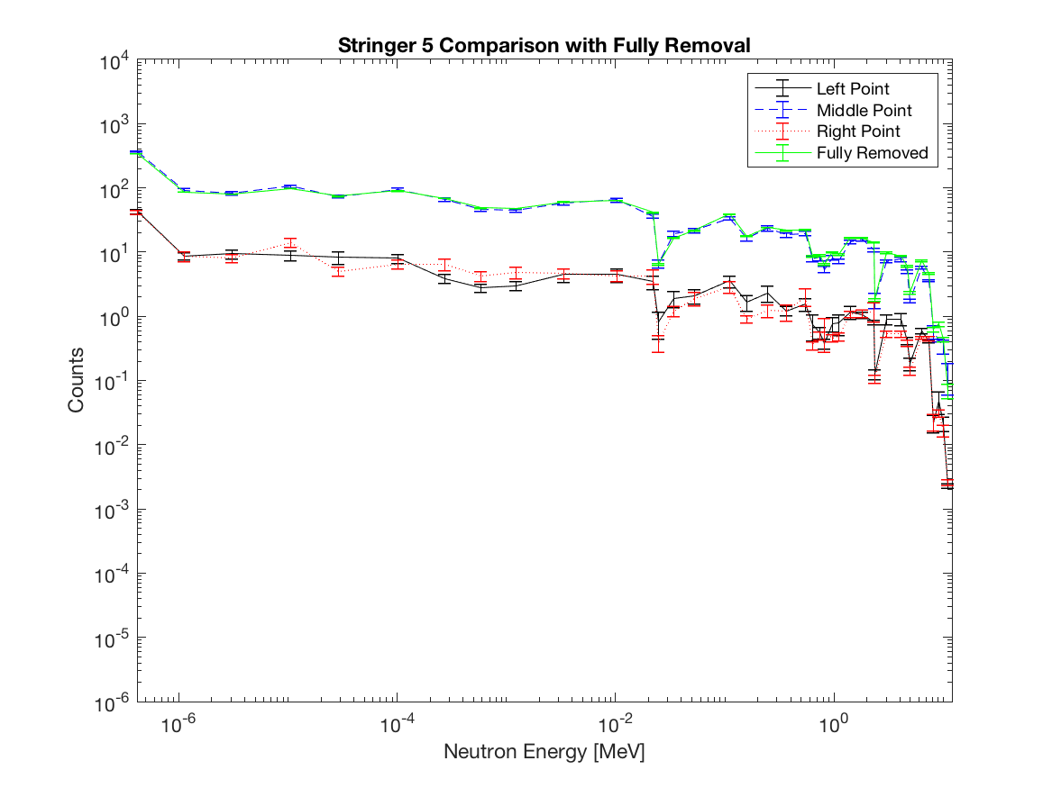

Fig. 7. Neutron energy distribution comparison of the fully removed stringer 5 with the point detectors.

# Conclusion

When conducting a lab experiment to characterize the image degradation of cameras due to neutrons, considered placement should be closer to the source because of the higher flux at higher energies with less variance. It is also important to reiterate that having to make minor adjustments position of a stringer that is not the source will not have a major impact on the energy distribution and flux in that stringer.

References

1. “AF NETF Graphite Standard Pile,” American Machine and Foundry Company Alexandria Division, Mechanicsville, VA, USA, Tech. Rep. WADD-TR-61-174, Mar. 1962.
2. J. E. Bevins, “Calibration of AFIT Graphite Pile to Account for 241Am Ingrowth in the 239PuBe13 Source,” Air Force Institute of Technology, Wright-Patterson Air Force Base, OH, USA.

1. Submitted for review on 1 June 2018. This paper is sponsored without direct financial support but through many hours of educational and moral support by the instructor of NENG 725, Monte Carlo Methods of Transport, Air Force Institute of technology.

   Will D. Johnston a master’s student at the Air Force Institute of Technology in the Department of Engineering Physics, Wright-Patterson AFB, OH 45433 USA (e-mail: will.johnston@afit.edu).

   .